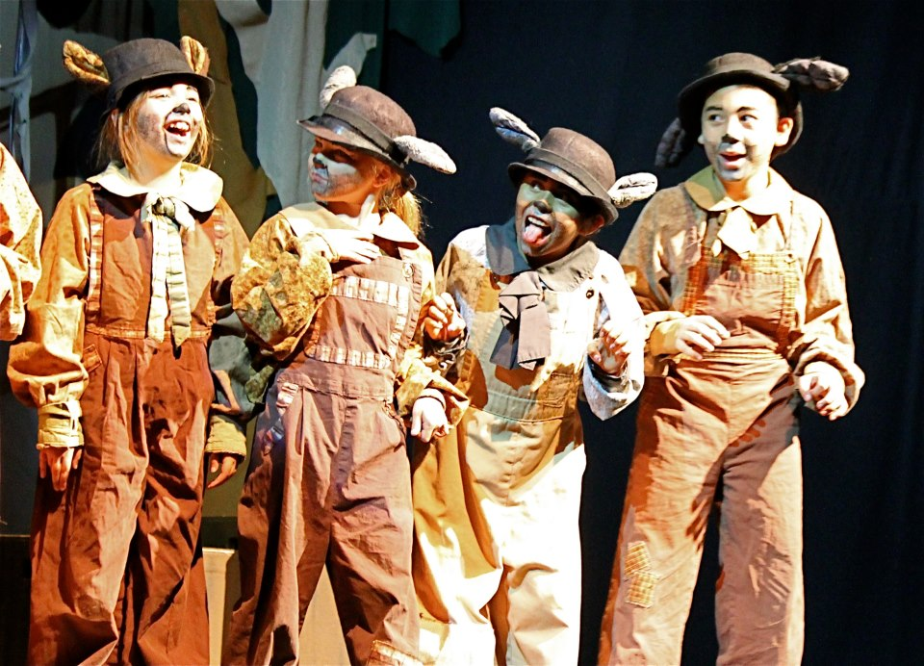

WELCOME TO THE THEATRE

Floyd Stephen Alexander
702.533.1583
Floyd1wd@yahoo.com
Floyd Stephen Alexander© 2014

About The Author: Floyd Stephen Alexander
Floyd Stephen Alexander is a playwright/actor/instructor/producer who works in both stage, film and television mediums and created many instructor/performance projects in live theatre. Loving to share his passion of theatre with young people, Floyd designed and wrote a instructing program, Welcome To The Theatre, which immerses the student in hands on instruction on acting, playwriting, costuming, lighting, set design and musical theatre. Children are more stimulated when they have an active role in the creation and dramatization of a story or event that has been presented to them. Welcome To The Theatre encourages the student to explore and actively participate in introducing aspects of the theatre arts. Welcome introduces the student to various elements in theatre history and dramatic presentation applied by a stage artist using word recognition, reading, speech, ensemble work, and stage presents. Decades of research in child development and recent research in brain development have proven that imaginative play contributes to a child’s optimal cognitive, physical, emotional and social development. It is their primary mode and most effective way of learning and be creative while doing it.
Floyd Stephen Alexander

NOTICE OF CONFIDENTIAL MATERIAL

The contents of this program are protected by manuscript infringement protection and copyright laws and are deemed confidential property of FLOYD STEPHEN ALEXANDER. Unauthorized copying, disclosure or use of this program without prior consent, is strictly prohibited. All inquiries and correspondence should be directed to:
Floyd Stephen Alexander
Author/Owner of Welcome To The Theatre
Telephone: 702.533.1583
Email: floyd1wd@yahoo.com
Welcome To The Theatre 1.
Exercise The Actor
-Physical / Vocal Preparation
-Word Knowledge
-Accents And Language
Audition: Interpreting Shakespeare
-Working The Script: “The Market Wedding”

Correcting Speech and Language
a. Language must show receptive and expressive speech.
b. Articulation must pronounce sounds correctly.
c. Fluency must show a uninterrupted flow of speech. Pause for breath at the right moments.
d. Voice must show correct voice volume, pitch, and quality
Stage Movement/Stage Layout
Instruct the positions on a stage and have students show were they are on different styles of theatre stages. (e.g. Where is Up Stage Right?/What is a Theatre In The Round?).
Act On Bullying: Using Theatre To Teach Recognizing and Challenging Bullying Activity
Role Play: What Is Bullying?
Saying Harmful Things: I asked my actors to define what actions were exhibited in bullying with “saying harmful things”. Many of the answers I got back were things like name-calling and taunting that bordered on ridiculing simple physical features to racial and ethnic stereotyping. I personally shared my own bullying experience when I showed them of picture of myself at age six (6) years old. My physical features were the fodder for many taunting opportunities by my peers. For my 2nd grader actors, I read out loud from a book entitled, A New Boy, by Eve Tol, and had my actors raise their hands when they heard any words or actions in the story that sounded like bullying. Without difficulty, they responded with a hand raised every time they heard a harmful word (i.e. “What a dummy!”, “Pick them up!”) or description of an action (i.e. “Boris stared at me and kept on playing. So I hit him and he cried.”).
Spreading Rumors: This activity was most informative to me with my actors citing incidences involving them being the victim of unwarranted gossip. Under the condition that no identities be given involving the perpetrator or the victim, I was regaled with stories of communicated falsehoods involving
Welcome To The Theatre 2.
relationships, gender identification, and group loyalty. Between 4th, 5th and 6th graders, this activity seemed to be one that was perpetrated the most.
Separating A Person From The Group: I had my actors create a scene showing how someone could be excluded from interacting with people in their peer group. I took pictures and videos of my actors interpreting ostracizing from a group setting.
References and Acknowledgements
1. A New Boy, by Eve Tol

2. A Little Princess, a film from the book by Frances Hodgson Burnett

3. The Secret Garden, a film from the book by Frances Hodgson Burnett

4. Various fairy tales and biblical stories

Basic Playwriting (With Pen In Hand)
Learning about creating a play applying the following elements:
-Plot.
-Characters.
-Setting.
-Point of View.
-Writing Dialogue
Lighting Design
Assemble/Disassemble Lighting Instrument (Table Lamp)
-Basic Wiring (Wire Strippers, Electrical Tape)
-Light Bulbs (Different Colors)
Scenic Design
Backdrop Painting
-Paint
-Paint Brushes
-Non-Fitted Bed Sheets
Welcome To The Theatre 3.
Make Up Design
Prosthetic Make Up Making
-Flour Dough Or Modeling Clay
-Hair Dyer
-Paint (Acrylic)
MUSICAL THEATRE
People Involved In Creating A Musical:
Composer: Person Who Writes The Music
Lyricist: Person Who Writes The Songs In The Music
Librettist: Person Who Writes The Book Or Libretto (Script)
Director: Person Who Stages The Musical
Choreographer: Person Who Stages The Dance Sequences
Actor: Person Who Plays The Characters

MUSICAL THEATRE
-SONGWRITING (“WRITE ME A TUNE”)
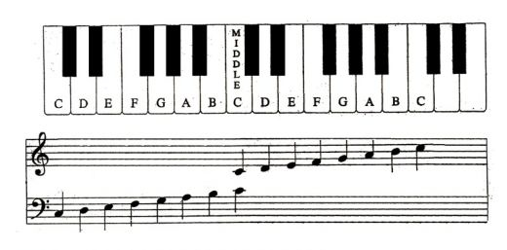
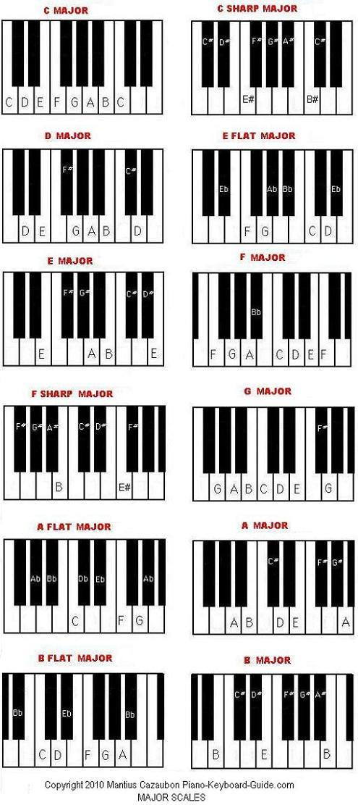
MUSICAL THEATRE
-SONGWRITING (“WRITE ME A TUNE”)
Welcome To The Theatre: Play Catalog of Floyd Stephen Alexander
Dracula

Wolf Man

J-Girls
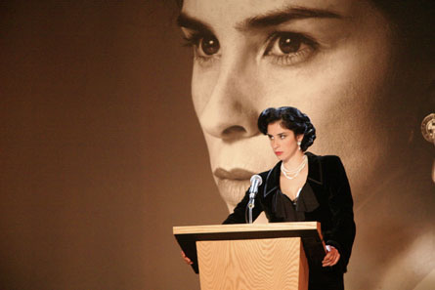

The Balloon Princess 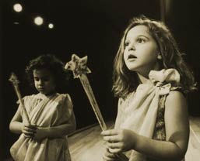

Scribes 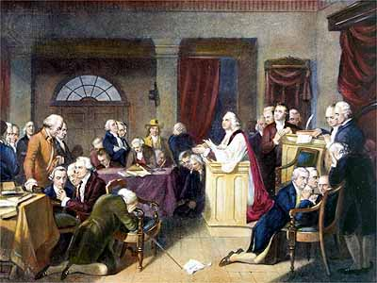
Floyd Stephen Alexander© 2014

Welcome To The Theatre: Play Catalog of Floyd Stephen Alexander

Notice of Confidential Material
The contents of this proposal are protected by copyright laws and deemed confidential. Unauthorized copying, disclosure, distribution or presentation of this proposal without prior consent of its author is strictly prohibited. All inquiries and correspondence will be directed to:
Floyd Stephen Alexander
Telephone: 702-533-1583
E-Mail: floydplaywrite@aol.com, floyd1wd@yahoo.com

By Floyd Stephen Alexander
Dracula

Synopsis: Two act stage presentation of Bram Stoker’s literary horror classic. A race for survival of human existence against a being of unspeakable horror.

Characters: Mina Murray-Harker
Lucy Westenra
Count Dracula
Dr. John Seward
Quincy P. Morris
Arthur Holmwood
Renfield
Jonathan Harker
Dr. Van Helsing

Floyd Stephen Alexander© 2014

By Floyd Stephen Alexander
The Balloon Princess

Synopsis: The Balloon Princess rules in the land of Heavenly located in the upper stratosphere of earth’s orbit. Her kingdom is made up of lost balloons that were carelessly let go to float into the air towards fates unknown. Full length stage play.

Characters: Princess Carrie
Beth
Dr. Abacus
Gar, The Evil One
Captain At Arms
Floyd Stephen Alexander© 2014
By Floyd Stephen Alexander
Wolf Man

Synopsis: In 1935 Mississippi, descendants of slaves live just a boat ride away from descendants of their former masters. A young Negro college student from the north arrives unrepentantly in research of an Afro-American genesis called Raven Hill. A gruesome murder is discovered and throws everyone into a panic. Only time will tell what terror lay in the woods on the bank of the mighty Mississippi.

Characters: Charles Whitesome
Sheriff Connor
Clifford Dunsfield
Taylor Brown
Lust Brown
Momma Tee
Bodell Simms
Delba
Wolf Man
Floyd Stephen Alexander© 2014
J Girls
By Floyd Stephen Alexander

A Celebration of Jewish Womanhood

Written in a compellation of dramatic scenes styled in poetic prose told by six storytellers. J GIRLS take the audience through scenes that ponder the questions of self-identity; family tradition; and maintaining a lasting friendship.
Characters: Ruth
Carrie
Abbey
Dayna
Julia
Rachel

Floyd Stephen Alexander© 2014
Welcome To The Theatre: Play Catalog of Floyd Stephen Alexander

By Floyd Stephen Alexander
Scribes
Synopsis: James Madison. Alexander Hamilton. John Jay. Three men tasked to solidify a promise of government “of the people, by the people and for the people”. View the making of a new nation.
Characters: Reverend William Spool
Sir Devon Smith
Delmond Renior
Doley Wilson
Hattie McKey
Cirus Holms
Alexander Hamilton
James Madison
John Jay
Floyd Stephen Alexander© 2014
Welcome To The Theatre: Play Catalog of Floyd Stephen Alexander
Short Plays for Scene Study and Character Development
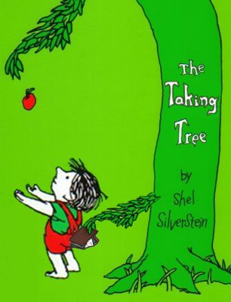 By Floyd Stephen Alexander
My Tree

Synopsis: A 10 minute stage play adaptation of the book, The Giving Tree by Shel Silverstein
(In Class Presentation Only)

Characters: Boy
Tree
Teenage Boy
Grown Man
Old Man
By Floyd Stephen Alexander
Adventures of Isabel

Synopsis: A 10 minute stage play adaptation of the book, The Adventures of Isabel by Ogden Nash
(In Class Presentation Only)

Characters: Narrator
Isabel
Witch
Warlock
Bear
Giant
Floyd Stephen Alexander© 2014
Welcome To The Theatre: Play Catalog of Floyd Stephen Alexander

By Floyd Stephen Alexander
Hannah The Little Red Hen

Synopsis: A 10 minute stage play adaptation of the book, The Little Red Hen
(In Class Presentation Only)
Characters: Hannah The Red Hen
Moses The Duck
Yakov The Cat
Reuben The Dog

Floyd Stephen Alexander© 2014
MANUSCRIPT CONTRACUAL AGREEMENT
Contract between Floyd Stephen Alexander and_________________________
This Contract Agreement on (Month/Day) 20_____________ between Floyd Stephen Alexander and _______________________, representative of ________________________________
The parties agree as follows:
1. This contractual agreement constitutes that the author, Mr. Floyd Stephen Alexander, will retain royalty fee and ownership of the manuscript,___________________, to be presented by your company,_________________, for the period of_________________ to_______________.
2. Compensation to Mr. Floyd Stephen Alexander, the author, must be paid in the form of manuscript rental and negotiable royalty fee.
3. Cancellation of the production before presentation will result in only payment of ten percent (10%) of the projected box office receipts of a sold out house.
4. There shall be no televising, broadcasting (radio, television, electronic devices), visual and/or sound recording, motion picture filming or video taping of the presenting manuscript,_______________, without permission from Mr. Floyd Stephen Alexander, author. When permission for such presentation is given, Mr. Floyd Stephen Alexander, the author, will be compensated from rental fees and/or payment charged to viewer of the manuscript,____________________ through those media forums listed above. Each viewing of the manuscript, ________________, is considered a single presentation for this viewing. Mr. Floyd Stephen Alexander will receive ten percent (10%) of the payment collected by your company, ___________________________
5. No changes or alterations to the presenting manuscript, _____________________, will be permitted without written approval from Mr. Floyd Stephen Alexander, the author. Request for change or alterations to presenting manuscript, ____________________, must be submitted by your organization, __________________, in writing, with specific details of those changes or alterations requested.
6. Floyd Stephen Alexander, the author, will receive billing (typographical credit) on all publicity programs and advertising campaigns involving your company’s,_________________, presentation of the manuscript, _________________. Failure to provide said billing is considered a breach of Mr. Floyd Stephen Alexander’s, the author, rights.
The parties have signed this contract agreement on the date specified at the beginning of this contract agreement.
_________________________ ______________________________
Floyd Stephen Alexander Client
___________________ ______________________
Date Date

